Luxulyan Neighbourhood Development Plan
Pre- Submission Draft
February 2018

1. Introduction

1.1 A neighbourhood plan concerns the future housing and commercial development in the parish. It is also about the use of land and the environment. The plan must take into account what local people want and can only be approved once a local referendum has taken place. The neighbourhood plan, will form part of the statutory development plan for the Parish and therefore, any planning decisions need to be made in accordance with the neighbourhood plan.

1.2 The creation of a neighbourhood development plan is part of the government’s approach to planning, as contained in the Localism Act 2011 (the Act).

1.3 Luxulyan Parish Council applied to Cornwall Council, on 4th June 2016, to designate the Parish as a “Neighbourhood Area.” Cornwall Council formally designated the Neighbourhood Area on 4th August 2016 in accordance with the Neighbourhood Planning (General) Regulations 2012.

1.4 The aim of the Luxulyan Parish Council producing a Luxulyan Neighbourhood Development Plan (LNDP) is to put forward the wishes of the local community with regard to any future development. In order to do this a Steering Group was created, this group included members of the Parish Council and also local residents, all of whom volunteered their services for this process.

2. The Neighbourhood Development Plan Process

2.1 The plan period of the LNDP is from the 1st September 2018 to 30 September 2030, a period of 12 years.

2.2 The process for the creation of the LNDP included: -
- Luxulyan Parish Council consulted residents and other interested stakeholders on the designation of this area.
- The consultation ran between Wednesday 22 June and 3 August 2016.
- To provide information about what a Neighbourhood Development Plan is, and to advertise a community event, a flyer was issued and circulated with the parish magazine.
- A community consultation event was held on 9th July 2016 in the Village Hall.
- Questionnaires were issued to get general indication about people’s views and concerns.
- This process was assisted by Cornwall Rural Community Charity and a grant was obtained to pay for support.
- Following these initial discussions, a Steering Group was formed with the initial meeting being held on 14th November 2016.

2.3 The Steering Group put together a survey which was then distributed to all households within the Parish during September 2017 inviting them to make comments and observations on a number of different topics. To publicise the survey two exhibitions were held on Saturday 2nd September 2017 at the Plant Swap and coffee morning in Luxulyan Memorial Institute on Saturday 9th September 2017 as part of the twentieth Anniversary celebrations held by The Friends of Luxulyan Valley at Luxulyan Village Hall. Following the consultation and questionnaire the analysis of the responses reveals 611 questionnaires were sent out, 163 completed responses were received. This equates to 27% return.

2.4 The results of this survey will be further discussed in Section 5 with the survey results being published in detail as part of the Evidence Base Document (EBD).

2.5 The LNDP contains policies that have been put together on the back of the survey results in conjunction with the policies and guidelines set out in the other relevant national and local plans. These policies can be seen in Section 7. Once these policies have been agreed and accepted they will form part of Cornwall’s Development Plan and they will become a “Planning Consideration” which will ensure that the voice of the Parish is heard in any future developments.

3. Guidelines

3.1 There are two senior tiers of planning legislation and guidance that it will be necessary for the LNDP to follow:
- The National Planning Policy Framework (NPPF) – This is national legislation that Local and Neighbourhood Plans must follow. It states:
‘Neighbourhood planning gives communities direct power to develop a shared vision for their neighbourhood and deliver the sustainable development they need. Neighbourhood Plans must be in general conformity with the strategic policies of the Local Plan, neighbourhood plans should reflect these policies and neighbourhoods should plan positively to support them. Neighbourhood Plans and Orders should not promote less development than set out in the Local Plan or undermine its strategic policies’
- The Cornwall Local Plan: Strategic Policies 2010-2030 (CLP) – This is the adopted local plan for the county.

3.2 The LNDP has been prepared in accordance with the NPPF, the CLP November 2016, Neighbourhood Planning Regulations 2012 and the European Directive on Strategic Environmental Assessment 2004.

3.3 In line with the CLP, the LNDP will cover the period from its acceptance by the Council to 2030.

3.4 This LNDP will be subject to an independent examination. It must demonstrate that the policies contained are consistent with the basic conditions as set out in the Regulations.

4. Description of the Parish

4.1 Luxulyan is a rural parish with an historic church town and dispersed hamlets, reflecting a traditional settlement pattern in the Cornish countryside. In addition to this there are significant areas of historic and archaeological importance, including part of a World Heritage Site and Areas of Great Landscape Value.

4.2 There are extensive areas of protected habitat, including Sites of Special Scientific Interest. It is predominantly agricultural, including larger farms and smallholdings, with one major employer, which is a meat-processing plant in a hamlet north of the village providing some local employment, and additionally other businesses/organisations employing between 10 and 30 staff. In the village, there is an industrial estate, a primary school, a pub and a shop. Most people in employment travel to nearby towns. Most people live in Luxulyan village, which includes 5 estates dating from the 1960s onwards. There is a mix of housing types, as well as two residential sites with park homes. Within the parish there are several residential sites occupied by travellers. In the village and most hamlets modern housing types (1960s onwards) predominate. There are two main meeting venues, the Village Hall and the recently refurbished Memorial Institute. The parish church forms a focal point in the village. The Saints’ Way footpath passes through the parish, as does a National Cycle Route. Many people come to the village in order to visit Luxulyan Valley World Heritage Site.

4.3 The current census information states there are 1800 inhabitants and 778 homes in the Luxulyan area [1441 for Luxulyan parish – 2014 ONS population estimate]. Of these residents 260 are under 15, 1030 of working age 15-65, and 510 are over 65. Caravans or temporary dwellings make up 11.5% of the homes. The largest sector for number of businesses is Agriculture at 19%, followed by Construction with 13% and then Professional/Technical with 11%.

4.4 There are 56 listed buildings and 7 scheduled ancient monuments within the Parish. The landscape of much of the Parish is described as rolling, with small to medium scale field pattern, with sinuous boundaries [classified as anciently enclosed], closely linked to the settlement pattern of dispersed farming hamlets. In some places this field pattern has been altered to create larger fields. These open fields are balanced by the frequency of trees and small woods, often occurring as dense mixed woodland on the sides of incised valleys (Cornwall Landscape Assessment 1994 - Cornwall County Council).

5. View of the Community

5.1 The following is a brief summary of the some of the areas covered within the questionnaire survey. The full results are published separately.
- The vast majority of respondents want future development to be within existing settlement patterns. However, a significant number of responses indicated that this could be mitigated if the development was providing lower cost houses for people with a local connection.
- The potential for low-cost housing could be sited to the north of the village centre, between Bridges/railway line to Chapel Field.
- There were a significant minority of negative responses to further development.
- The responses reinforce the need for housing to support local people and local facilities, e.g. the school. There is little appetite to develop homes that encourage new people into the parish, therefore, any future planning agreements should be specifically aimed at supporting local housing needs and community facilities.
- 62% of the respondents believe that new homes should be spread among a greater number of small sites, to help meet the ambition of the community to promote affordable housing for local people.
- The responses show a definite wish that new houses should be of a smaller size for smaller family/start-up homes and homes adapted for older people.
- The responses about the tenure of new homes indicates a mixture of priorities but primarily that people would like to own, or part-own their own home, provided there was an opportunity to buy or part-buy at a realistic price. However, a significant number of responses also felt it was important to have more homes for rent.
- Respondents felt new homes should be energy efficient and there should be a mix of homes that match the existing styles in that particular locality.
- 35 responses indicated a lack of available properties that are affordable to buy or rent (this has included people having to buy outside Luxulyan parish when they would rather have stayed, these specific examples reinforce the need to prioritise local needs as regards to housing).
- When asked about employment in the Parish the majority of people felt it was reasonably important to create extra job opportunities, it wasn’t given as high a priority as might have been expected, employment in the parish is an important factor and serious consideration should be given to support planning applications which don’t impact adversely on residential amenities or protected designated areas.
- People in the parish would prefer small businesses to be set up and suggestions varied from retail outlets/cafes to IT/office to light industrial units a few of the suggestions would not be sustainable given the size of the village/parish. Current infrastructure/road links are not adequate for any larger scale business, some comments suggested that there should be no further business expansion.
- There is a significant concern about the speed and volume of traffic. There were also a number of concerns about larger vehicles/tractors.
- The responses seem to indicate that most people are happy with the character of the parish as it is but understand the need for development (homes and employment) as long as it is in keeping with the nature of the parish. There are some concerns about the capacity of the infrastructure to cope with too much expansion.

6. Vision and aims

6.1 The vision for Luxulyan Parish is:
- Maintain the existing character of the parish as a viable working rural area.
- Ensure that local people can shape the future development of the parish, including the scale, type and tenure of housing in order to meet identified local needs.
- Improve and enhance the existing community spirit so that everyone feels that they belong and are valued.
- Encourage quality of life for all inhabitants, including vulnerable groups.
- Protect and celebrate natural and historic environment and promote activity that is environmentally sustainable.
- Support small-scale employment opportunities.
- Develop transport links that accommodate motor vehicles whilst encouraging cycling, walking and horse-riding.

6.2. To meet the vision a number of aims have been identified and are outlined within the policies:
- To meet future housing needs of the Parish. (Policies LH 1-4)
- To encourage suitable business development. (Policies LRE1)
- To protect the Natural Environment and Open Spaces. (Policies LLNE1)

7. Policies

7.1 The LNDP contains a series of policies, the successful delivery of which during the plan period will meet the aims and, in turn, achieve the community’s vision for the Parish.

7.2 The policies are in bold. The intention stated for each policy contains background, explanations and rationales.

Housing Policies

7.3 The Parish of Luxulyan lies within the St Blazey, Fowey, and Lostwithiel Community Network Area (CNA), which is one of 19 CNA’s in Cornwall. The CLP allocates 900 new dwellings to this CNA, 715 of these have been built or have planning permission, the remainder are to be derived as ‘windfall’ sites between 2021-30.

7.4 The CLP has not set a specific housing requirement for the Parish but has set a minimum target of 185 new dwellings for the CNA. As at March 31st, 2017 for the whole CNA there were 412 completions and 303 dwellings with the benefit of planning permission, or under construction. Cornwall Council advises the CLP calculated disbursement for the CNA provided a housing target for the Parish of 68 houses, of which 46 have been built, or have planning permission. This leaves a further 22 to be developed by 2030.

7.5 The LNDP seeks to accommodate this proposed housing growth by prioritising affordable homes for local people through small scale windfall opportunities whilst retaining the essential rural character of the Parish. Infill development should be proportionate to the scale of any settlement and within its boundaries, respect the settlement and landscape character of the locality and not physically extend the settlement. It must clearly relate to part of an established settlement and not as isolated dwellings.

New Housing

7.6 Reasoned justification
The location of new homes should reflect the character of the area in terms of design and layout, making the most efficient use of the land available and achieve an appropriate density for the parish. The LNDP will support infill development and exceptionally ‘rounding off’ if it is in the identified LNDP Housing Zones and where it accords with the CLP Strategic Policies 3 and 9. Further guidance can be found at http://www.cornwall.gov.uk/media/30558877/cpoan-infill-rounding-off-4-12-17.pdf

7.7 Luxulyan is a rural parish, with the traditional Cornish settlement pattern of a Churchtown (village) and dispersed hamlets and farms. It is clearly the wish of local people, according to the questionnaire responses, for the rural character to be protected by the planning system.

7.8 The settlement pattern, including the village, hamlets and farmsteads, buildings, field hedges, and the network of sinuous, narrow roads, derives from the medieval period when the economy was based heavily on farming and tin streaming. The Industrial Revolution brought changes, largely as a result of industries such as quarrying, and the transport infrastructure developed by Treffry in the Luxulyan Valley. This period saw the emergence of new settlements, such as Bridges and Lockengate, and the late enclosure of land in the north of the parish. Tin streaming continued but deeper mining was not of great importance within the parish. Although on the periphery of the china clay industry, it did have some impact on the parish, with some clay extraction, as well as the construction of clay dries.

7.9 In Luxulyan Churchtown, slate-roofed granite cottages for working people, chapels, pubs, a tramway, and then the railway, appeared, adding another layer to the medieval settlement pattern but the basic rural character remained. Since the late 20th century, 5 housing developments have appeared in the village and Bridges. These have not followed any consistent design and do not conform to the styles or materials used in the past. These developments have had an impact on the village character, and its infrastructure, although it retains its rural feel. Nor has this feeling of peacefulness been adversely affected by the role of the village as a hub for people visiting the shop and post office, or attending the school, church, memorial institute or village hall. The peaceful setting and character of the village was commented on very favourably by respondents to the questionnaire, and there is a concern that further, large developments might jeopardise the character of the village. Additionally, the mature trees in the former vicarage, and the churchyard, contribute significantly to the feeling of tranquillity in the village centre. Even though the Churchtown and Bridges have been joined by modern development, they are surrounded by farmland and remain separate from nearby hamlets, such as Rosemelling and Treskilling. This is clearly a situation that residents wish to protect.

7.10 Similar vernacular architecture to that in the Churchtown is evident in the outlying hamlets. As is the case in the main village, modern domestic architecture in the hamlets does not generally conform to the traditional style of granite walls and slate roofs but development has been small-scale, so the basic character has survived. It is clear from the questionnaire responses that there is a strong wish for the boundaries of these hamlets to be respected in future planning.
7.11 In addition to the Churchtown and the hamlets, two other settlement types deserve mention: there are two residential park home sites, at Atwell and Croft Farm; and there are various Traveller sites, some of which, for example in the Gillies and Conce area, date back to the early twentieth century and probably earlier.

7.12 Modern industry is mainly small scale, although the exceptions are the meat-processing plant at Ebeneezer, the concrete works and scrapyard at Carne Cross, and two large solar farms. Smaller workshop-based enterprises have developed near the railway station and at Penince. Farming remains the most important activity in terms of land usage.

7.13 Any proposals for development outside the settlement boundary must not impact on the existing open breaks between settlements which serve to retain and safeguard their individual identity and character.

7.14 Intention
To identify an appropriate zone for future housing while retaining existing settlement patterns to meet the evidenced local housing need identified in the CLP and local Neighbourhood Plan survey.

Relevant Higher Level Policies
NPPF paragraphs 50, 54 and 55
CLP Policy 1, 2, 3, 7, 13, 14, 22, and PP9

Possible zones for future affordable housing

7.15 The zones may be divided into:
- Housing Zone 1. Land around the station and the Beswetherick Fields development; and
- Housing Zone 2. Chapel Field - land identified under the Strategic Housing Land Availability Assessment 2012 – 2015 (http://www.cornwall.gov.uk/community-and-living/mapping/ )

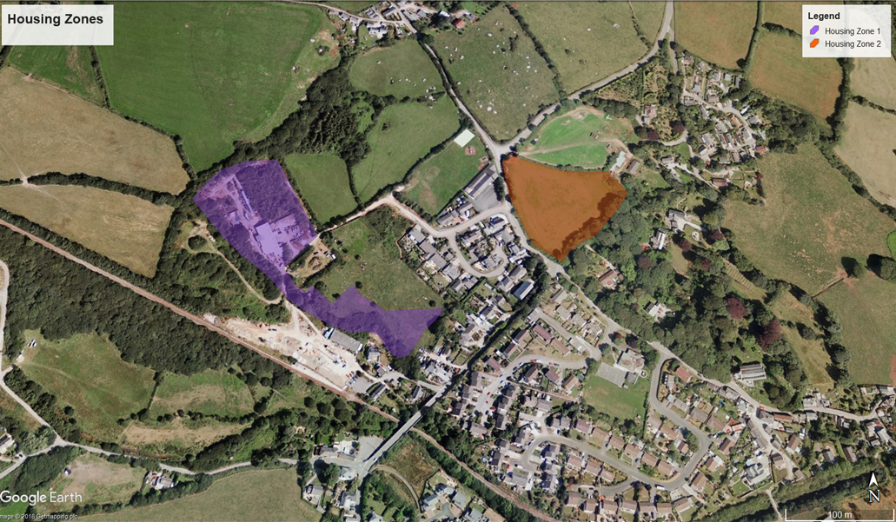
LH1 - Settlement Pattern
a) Housing proposals will normally be expected to fit within existing settlement patterns as infill and being proportionate to the existing settlement pattern.

b) Proposals for housing development must not impact on:
- undeveloped gaps that form an important break in development between built surroundings;
- prominent local physical features within the settlement that contribute to its character.

Rural Exceptions Housing for Local People

7.16 Reasoned Justification
There is a general need for low cost, high quality housing in the Luxulyan Area, which is evidenced by the survey. Therefore, based on past development of new housing around the Parish and looking forward over the plan period the Parish Council considers priority is given to housing under the following policies which would deliver twenty-two new homes by 2030. The following policies allow new housing which is defined as low cost by reason of its limited size. These are expected to include new build, conversions of existing buildings and lifting of current restrictions on holiday accommodation. Where new dwellings are proposed these should preferably be within the curtilage of existing properties.

7.17 These policies seek to protect the future of local families and the sustainability of the community. Further evidence of house prices as a multiple of earnings suggests that many emerging households are (and will be) unable to buy or rent housing, particularly if they wish to stay local to the Parish, family or community links. These policies recognise the Community’s concerns about the provision of new housing in the Parish and relaxes the existing constraints and those in the Cornwall Local Plan on providing rural housing. This will provide more and appropriate sites within the Luxulyan area where the opportunity and the need for low cost housing will coincide. The provision of housing which is secured as low cost in rural areas can benefit, not only the initial occupier(s), who may have work, family links, caring responsibilities or simply the best opportunity to provide a suitable house for themselves, but it will also benefit the local community by ensuring that the dwelling is available after initial occupation to those in housing need in the future from the Parish. Such housing may provide additional benefits in terms of sustaining the local community, the school or providing opportunities for more employment.

7.18 Intention
The intention of Policy LH2 is to allow local people to access housing which is achievable and affordable to them in the Parish. This policy is intended to help those local people who have access to land or buildings and who cannot afford to buy or rent on the open market but who have the means, skills or ability to convert existing buildings or build a new house for themselves. A low-cost dwelling is defined as a one bedroom or two-bedroom bungalow, flat or house, restricted in size.

7.19 The Questionnaire showed a definite wish that new houses should be of a smaller size (1-3 bedrooms) for smaller families/start-up homes and homes adapted for older people.

Relevant Higher Level Policies
NPPF paragraphs 50, 54 and 55
CLP Policy 1, 2, 3, 7, 13, 14, 22, and PP9

LH2 - Rural Exceptions Housing for Local People
Rural exceptions sites for single plot affordable housing will be permitted to meet a local need where this need is evidenced and where the development does not have an unacceptable impact on the visual and landscape amenity of the area. This may be acceptable in the case of either new build dwellings or conversion of traditional buildings. In each case ancillary works such as access, outbuildings, curtilage boundaries also should not have an unacceptable impact on the visual and landscape amenity of the area. These developments will need to consider how the balance of benefits such as any social, economic, environmental or community benefits for the intended occupier or wider local community justifies the proposal. This policy operates throughout the plan area and no size restriction applies. Affordable housing for local people will be secured as such for its longevity through a Section 106 Agreement.

Permitted Development rights will be removed to ensure the justification for the dwelling remains linked to housing need and affordability.

The following criteria apply:
1. The proposal is to deliver a small, lower cost home
2. The proposal should be well-related to existing hamlets and houses
3. The property has a maximum of 2 bedrooms although up to 3 bedrooms may be considered in exceptional circumstances
4. The property must be used as a principal residence.
5. The house has a maximum size of 60sqm for a one-bedroom property or 90 sqm for a 2-bedroom property. Any garden area must be less than 300sqm.
6. All Part 1 permitted development rights from the TCPA (GPDO) 2015 will be removed by planning condition.
7. Applications to extend or otherwise enlarge these properties will not normally be supported.
8. Self-build, modular and other innovative low-cost housing models are encouraged under this policy.

This policy applies to new build properties and to the conversion or re-use of existing buildings, including where appropriate the change of use of holiday units to permanent residential accommodation where the above criteria are met.

Housing on Farms

7.20 Reasoned Justification
Providing flexibility for farmers (or rural businesses) is an important objective if farms in the Luxulyan area are to remain viable and family owned and run. Farms in the area may already have unrestricted dwellings associated with the enterprise. This allows the farmer to use a second dwelling for family members, to help manage generational transition, create extra income through holiday letting, or simply to allow local people to rent a dwelling. However, current planning policy is silent on allowing such flexible use of dwellings on farms. It tends to expect that farmers want either to provide holiday letting accommodation, or housing for an agricultural worker, or to provide a form of low cost housing. All of these possible planning consents are tightly controlled without any in-built flexibility. To provide new housing on farms which has this flexibility will give the farmer better control of the business, allow easier investment decisions, and allow family members to remain on hand for changing circumstances within the sector or within the family. Where new housing is required, for any of these purposes, a justification for it should be made in relation to at least one the purposes, or a combination of purposes. In terms of local housing need, evidence of a housing need will be required; in terms of managing generational transition, the family circumstances should show that either one household is retiring, or one household is emerging and engaged in farming or caring for another family member; in terms of holiday letting, a viability assessment showing that the income from the new dwelling will help ensure the viability of the farm (or rural) business.

7.21 Intention
This policy is intended to help existing farms or established businesses remain viable, family run, or provide rented accommodation for local people. The safeguard to prevent abuse of this policy is to ensure that these dwellings are to remain an indivisible part of that farm or rural business. New houses allowed under this policy will be subject to conditions that they will only be occupied by persons with a local connection.

Relevant Higher Level Policies
NPPF paragraphs 28, 50, 54 and 55
CLP Policy 1, 2, 3, 7, 13, 14, 22, and PP9

LH3 - Housing on Farms
Established farm enterprises or rural businesses may have additional dwellings that can be used by family members, holiday letting or renting to local people.

Applications for any additional housing must be accompanied by justification for at least one of the forms of housing that the policy intends to permit. In addition, it will be subject to a Section 106 Legal Agreement which specifically permits the use of the property to housing for family members, holiday letting, farm worker, and for rent to local people. The Section 106 Agreement will prevent the sale of the property except as part of the farm enterprise or rural business or alternatively, as an affordable dwelling.

Consideration of the siting and design of such new houses will be important to allow both the flexibility that the policy intends and also ensuring that there will be no unacceptable impact upon the visual or landscape amenity of the area. The reuse of an existing traditional building within the landscape or a suitable plot within or near to the existing farmyard, may prove to be a suitable site.

Such development should be limited to a maximum of 3 properties per farm where such a need is clearly demonstrated. ‘Local people’ shall include only those who live or work within the Parish or have immediate family ties within the Parish.

Housing for Older People

7.22 Reasoned Justification
Steps need to be taken to facilitate the delivery of housing for older people. The Luxulyan area has a high proportion of older people and owner occupiers. As an appealing area it has attracted inward migration of households often through downsizing from more expensive areas of England. When those households need more specialised housing there is at times a lack of choice and there is the possibility of older people occupying larger unsuitable properties. Currently there is no housing stock tailored for the elderly.

7.23 Intention
The policy seeks to balance the need for more general low-cost housing; these will be restricted to one and two-bedroom housing which is the priority for the Luxulyan area for younger and older people in housing need. In the Parish as an addition to exception sites for the delivery of low cost housing this can be augmented by the provision of an older person’s household. To qualify for consideration older persons housing should be restricted in price to no more than the mean local housing price and be available only to those local households that are unsuitably housed and whose household income is no more than the mean local household income. These will also free up larger houses in the Parish for families.

7.24 These homes could be available to rent as well as well as buy. New homes under this policy should be located in the centre of the village for easy access and community inclusion, and in existing settlements close to family support networks.

Relevant Higher Level Policies
NPPF paragraphs 50, 54 and 55
CLP Policy 1, 2, 3, 7, 13, 14, 22, and PP9

LH4 - Housing for Older People
Within the Parish housing developments should address the local need for older persons’ housing. This can occur through the provision of bungalows or other suitable housing types restricted to occupancy for those local households where one person is over state pensionable age.

Proposals when at least one occupant is over state pensionable age (or requires specialist housing by virtue of personal incapacity or impairment) will be assessed and supported where the following are met:
a) meeting the needs of an identified older local person in housing need;
b) releasing an unsuitable dwelling into the market or, for transfer to a family member;
c) does not have an unacceptable impact on the visual or landscape amenity of the area.

The new dwelling will be subject to a s106 Legal Agreement ensuring that it remains available for local households where one member is over the state retirement age, or as an affordable dwelling for local people in perpetuity.

Extensions and annexes
7.25 Reasoned Justification
The increase in the elderly population and the need for housing for young people who have not left home leads to an increased need for extra accommodation and for homes to adapt to changing circumstances. In addition to the need for extensions to provide additional accommodation there is a trend towards small businesses being run from home. Superfast broadband will likely accelerate this trend.

7.26 Intention
The LNDP recognises that there may be occasions where extensions or conversions are required and will encourage these subject to retaining residential amenity and the quiet and quality of the Parish.

Relevant Higher Level Policies
NPPF paragraph 58
CLP Policy 1,2,7,13,14 and 22

LH5 - Extensions and Annexes
Proposals for extensions or annexes will be supported subject to the following:
(i) there being no significant adverse impact upon the residential amenities of adjoining properties through loss of privacy, loss of daylight, visual intrusion by a building or structure, loss of car parking or loss of mature vegetation or landscape screening;
(ii) the design of any extension or annex is subsidiary in size and sympathetic to the character of the existing dwelling;
(iii) due consideration is given to retaining proportionate garden space, trees, planting and landscaping in keeping with other dwellings in the surrounding area;
(iv) the development is in keeping with its setting and respects the distinctive local character of the area in terms of bulk, scale, height and materials;
(v) safe access and adequate parking are available or can be provided;
(vi) a condition will be imposed to ensure that the extension or annex is retained as ancillary to the main dwelling and not used as a separate unit without the consent of the planning authority.

In addition to the above, to ensure there is no abuse of the general presumption against new dwellings in the open countryside, the Local Planning Authority will require that:
(vii) an extension or annex is physically attached or closely related to the existing dwelling and is of a size and layout to facilitate its eventual integration into the main house;
(viii) conditions will be imposed, or a Section 106 agreement sought, restricting occupation of extensions or annexes to the main householders or their relatives or dependents, to ensure that the annex remains ancillary to or is integrated into the original dwelling if the original circumstances justifying the development cease to exist.

Standard undertaking required
7.27 Local Occupancy Condition
Housing permitted under policies LH1 - 4 are required to be restricted for local occupancy only. The following restriction will be used to secure this: -

Properties restricted for local occupation only shall only be occupied by a person or household who: currently lives in the relevant locality and has done so for a continuous period of at least three years; and/or works in the relevant locality and has done so for a continuous period of at least three years; and/or has moved away but has strong established and continuous links with the relevant locality by reason of birth or long term immediate family connections; and/or has an essential need through age or disability to live close to those who have lived in the relevant locality for at least three years; and/or has, for whatever reason, the written support of the Parish Council.

7.28 The definition of ‘locality’ refers to the Parish of Luxulyan in the first instance, and if, after an initial period of active marketing an occupier cannot be found, a second active marketing period would allow the definition to cascade out to include the adjoining parishes, a third period of active marketing would eventually cover the County.

7.29 Adjoining parishes are defined as the parishes of Lanivet, St Blaise, Lanlivery, Tywardreath and Par, Roche and Treverbyn.

7.30 Following the third period of active marketing, if still no occupier has been found the property may be occupied on the open market.

7.31 “Active Marketing” means the advertising for sale or letting of any interest in the relevant Low-Cost Dwelling for not less than 90 days at each stage, a total of 270 days, in accordance with a scheme to be approved by the Parish Council (such approval not to be unreasonably withheld or delayed) which scheme shall include unless otherwise agreed with the Parish Council:
(a) In the case of Low Cost dwellings for sale an advertisement on the website of Help to Buy South West or any other similar organisation promoting intermediate market housing; and
(b) Such other local advertising as shall be agreed in writing by the Parish Council, including local estate agents, newspapers and two national property websites.

Older persons housing planning condition
7.32 In addition to the local occupation restriction, dwellings permitted under LH4 are to be restricted to occupation by older people, or for people with particular personal incapacity or impairment. The following condition will be used to secure this:

The properties restricted for older people’s occupation only shall be occupied by a person or household comprising at least one person who has reached the State Retirement Age which applies at the date of their first occupation of the property. This condition is deemed to be met if the State Retirement Age subsequently exceeds the occupier’s age. The properties restricted for occupation by people with a particular personal incapacity or impairment shall be occupied only by a person, or household comprising at least one person, who requires specialist accommodation as a consequence of that incapacity or impairment.

Gypsies, Travellers and Travelling Showpeople

7.33 The LNDP supports CLP Policy 11 relating to new residential and transit sites for Gypsies, Travellers and Travelling Showpeople. However, in response to a significant number of questionnaires returned expressing concern about the size of existing sites in the plan area, the LNDP does not support proposals for extensions to existing sites.

Economic Development

7.34 Reasoned Justification
Economic growth in rural areas will create jobs and prosperity; there are a range of businesses in the Parish, farming being at its heart. Some residents have developed B&B businesses or holiday lets to supplement their income, but this is not the typical Cornish holiday area. Many residents in the community greatly value this area for its rural tranquillity.

7.35 This policy permits the development of new business premises of a scale and design in keeping with the character of the local area.

7.36 Exceptionally, where larger premises are required, developers will be asked to demonstrate that all the criteria set out in the policy are satisfied and that there is a need to locate the building in the area and that there are no existing buildings in the area that are suitable for conversion to the proposed use.

7.37 Intention
To support economic and employment opportunities whilst ensuring that any commercial and/ or industrial developments (individually or cumulatively) are sympathetically sited and do not impact significantly on landscape character.

7.38 To identify suitable areas for commercial/industrial development, for example small-scale enterprises such as at Penince. This may include re-use of redundant agricultural buildings providing that in any change of use that is considered great care is taken to ensure that there will be no material negative impact on neighbouring residential properties. The development of new businesses must include any improvements to infrastructure, e.g. roads, so not to disadvantage existing traffic flow.

LRE1 - Commercial Development
To support economic growth, proposals for economic development and premises for business and other development such as infrastructure or necessary utilities development (where they require planning permission) will be supported provided that it has been demonstrated that:
(i) the development does not involve building on greenfield sites unless there are no suitable, available or deliverable opportunities to re-use existing buildings or previously developed land (including buildings and land already in commercial use);
(ii) the development does not entail building on good quality agricultural land Grades 3a or, where reasonable alternatives can be identified, Grade 3b agricultural land;
(iii) the development does not involve building on or immediately adjacent to land subject to statutory and non-statutory designations for wildlife and geological value or semi-natural habitat;
(iv) the development would not have significant harmful impacts on the natural and historic environment of the area or the built environment of the settlements;
(v) the development respects the character of settlements and any adjoining residential properties;
(vi) any extension or additions to an existing complex should be sympathetic in terms of scale, design and materials;
(vii) the development has regard to the Cornwall Design Guide, i.e. the design and layout of the development should create a minimal impact upon the surrounding landscape;
(viii) the proposal does not relate to areas subject to risk of flooding as identified by the Environment Agency;
(ix) the proposal does not require development on visually-exposed plateaus, ridges or skylines or on steep sided valley sides or any other visually exposed sites;
(x) the approach roads are capable of accommodating the volume of traffic generated on the development and a safe access can be provided;
(xi) adequate parking is provided;
(xii) the development should be suitably landscaped involving a mix of appropriate soft and hard landscaping retaining existing trees and hedgerows where appropriate;
(xiii) external storage areas should be appropriately landscaped and screened;
(xiv) the development should not cause a new or exacerbate an existing pollution problem where pollution is defined widely and includes chemical, light, noise and smell pollution;
(xv) adequate provision can be made for the disposal of foul and surface water drainage to the satisfaction of the local planning authority;
(xvi) appropriate provision is made for the protection of any significant wildlife interest which would be displaced by the development;
(xvii) special care is taken to ensure that bats, barn owls or other birds or their nesting areas or roosts are not disturbed.

Local Landscape Character

7.39 Reasoned justification
To protect and enhance the landscape and important areas of local green space and encourage its appreciation by local people and visitors.

7.40 The areas and features that the LNDP seeks to afford protection are those that have been recognised as being special. These areas include those with a statutory designation in recognition of their international importance, i.e. The World Heritage Site of Luxulyan Valley but also include those that do not have a statutory designation but have been recognised by Cornwall Council as being of local importance and given a local designation, such as in the Cornwall & Isle of Scilly Landscape Character Assessment (CA 39 St Austell Bay and Luxulyan Valley), County Wildlife Sites and the Area of Great Landscape Value.

7.41 The LNDP also seeks to retain the much-loved local scenery in keeping with the responses to the questionnaire to preserve the tranquillity, dark skies, Cornish hedges, quality of the landscape, unique granite boulders, village amenities, farming landscape, field patterns, trees & woodlands, stream, ridges & skylines, and historic features.

7.42 The area determined to be the most important to the landscape and historic setting of Luxulyan, by the responses to the questionnaire, is identified in yellow.

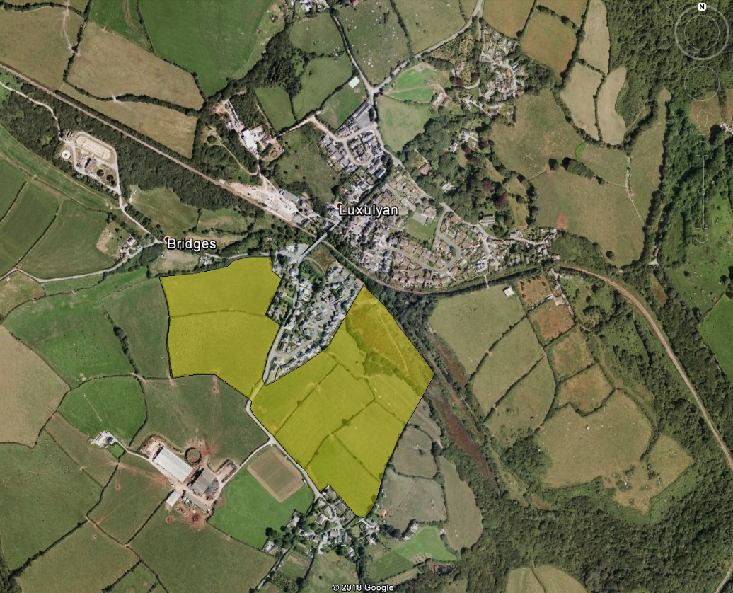

7.43 Intention
This policy seeks to maintain, and where possible enhance Luxulyan’s special, highly valued landscape and natural environment with its rich diversity, including a number of important habitats and species.

7.44 Development should be centred around and within existing settlements including the village, hamlets and farms as this is the current ethos of Luxulyan and the Parish. Large estate type developments will not be allowed, and any development must be sympathetic to the current housing density and pattern of the immediate area and village setting, in particular recognising the need for separation to be maintained between the historic setting of Luxulyan village and nearby hamlets, such as Rosemelling and Treskilling. No development will be supported in the area highlighted in yellow in the plan above.

Relevant Higher Level Policies.
NPPF paragraphs 9, 109 and 118
CLP Policy

LLNE1: Local Landscape Character.
Proposals for development will be supported where they have demonstrated that they respond to local character and reflect the identity of the local surroundings. Where development is proposed which will detract from, or have an adverse impact on existing landscape characteristics that have been identified by the community or by the Cornwall & Isle of Scilly Landscape Character Assessment as the essence of the character of the local area, it will not be supported.

8. Glossary of Terms

EBD – Evidence Base Document
CNA – Community Network Area
CLP – Cornwall Local Plan: Strategic Policies 2010-2030 May 2016 Examination
version
LNDP – Neighbourhood Development Plan
NPPF – National Planning Policy Framework
The Act – The Localism Act 2011
The Parish – Luxulyan Parish

9. Background Reference Documents

Basic Conditions Statement
Statement of Public Consultation
Copy of the Public Notice
National Planning Policy Framework March 2012
Planning Practice Guidance March 2014 (as amended)
The Town and Country Planning Act 1990 (as amended)
The Localism Act 2011
The Neighbourhood Planning (General) Regulations 2012
Cornwall Local Plan Strategic Policies Novemebr 2016
Cornwall Council Design Guide 2013
https://www.britishlistedbuildings.co.uk/england/luxulyan-cornwall#.Wjj6X01LGcY)

